 | WLTSC TENNIS COMMITTEE
Subject | Discussion points | Action
 | Minutes of Meeting held on 3rd Feb 2025
Present  Apologies | Darren Collinswood  Amber Fellows  Karen Fletcher  Lisa Callaghan -Butler  Andy James  Heather Hale  Max Thomson  Mike James  Manny Samra  Sav Alenza
Matters Arising | - Teams & Captains Meeting – for discussion later | ALL
Safeguarding | - No issues
News from the Chair | - Court 9 use  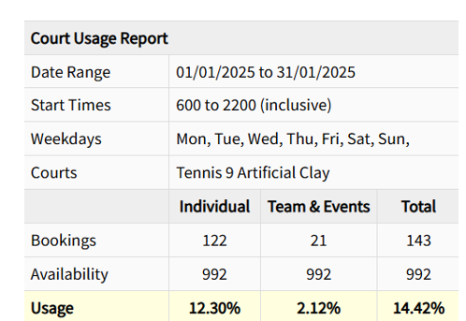  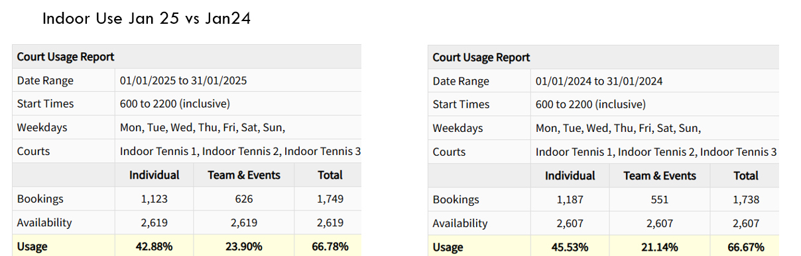 | ALL
Competitions and Internal Leagues | - Leagues going well  - Challenge cup launched, in progress and finals to be on 21st March with some subsidised catering.  - Coaches Cup 24th May  - Club champs finals to be 27th & 28th June  - 100 plus finals 22nd August  - Vintage and Vets to be run together with finals 20th September  - Who pairs wins to be run again this year with finals 22nd November  - DC to confirm sponsors for club champs and vets | MJ / DC
Teams | - Teams now registered with leagues  - Home dates will be sent to captains  - Reduced team number will be easier to fit  - Porsche Wolverhampton to be team home match ball sponsor  - Captains meeting will be scheduled for March  - Email to all members inviting interest in playing for teams | DC
Adult Programme | - Aussie open feedback – great night well done Amber AND the restaurant, the subsidising got 24 people signed up and in the bar. Curry club night to be held in March with future nights around food not Grand Slams, other than Wimbledon whites  - Beginners tournament this week  - Improvers / handicapped tournament  - Half term ad-hoc sessions  - All classes going well – most maxed out | AF/DC
Junior Programme | - 142 + 11 Newbridge Children per week – Newbridge numbers reduced  - Monday red and Saturday 10am yellow need pushing. DC suggested other use of court and coach time at 10am to provide members with something.  - Half term camp online and being pushed  - DC to meet MT to discuss LTAs | MT
SEND and Junior Development
AOB | MT asked about coach opportunities around padel. DC will speak with SC and get answer for next meeting. | ALL

Next Meeting Monday 3rd March 2025

