 | WLTSC TENNIS COMMITTEE
Subject | Discussion points | Action
 | Minutes of Meeting held on 10th October 2005
Present  Apologies | Darren Collinswood  Max Thomson  Marylin Goodwin  Manny Samra  Amber Fellows  Lisa Callaghan Butler  Mike James  Andy James  Heather Hale  Sav Alenza  Max Thomson
Matters Arising | - Tennis Night – Details discussed. To be pushed in January  - Team Captain night – will be arranged after league AGM to confirm new rules.  - Court 9 tent - in place | ALL
Safeguarding | - None
News from the Chair | 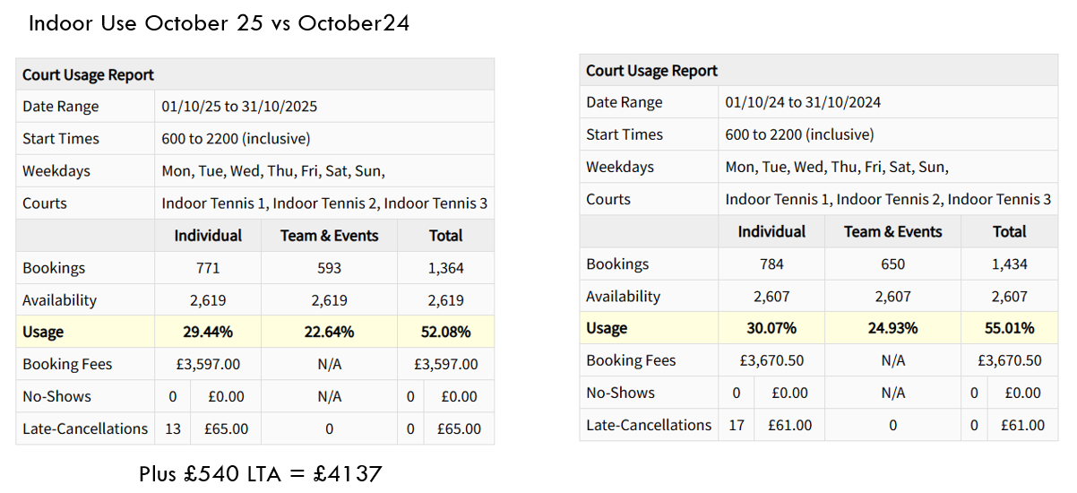  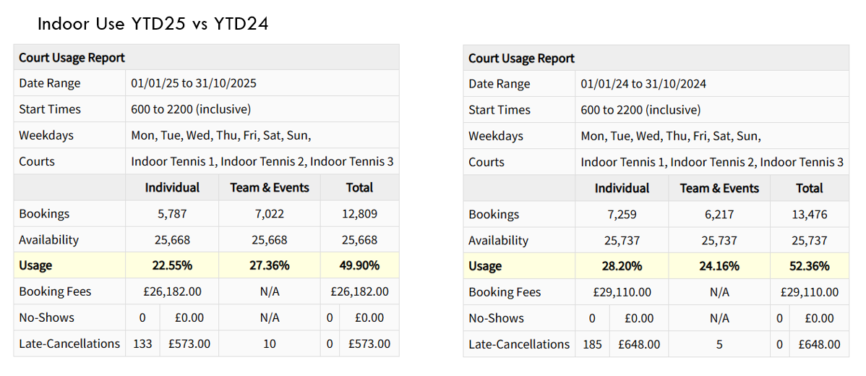  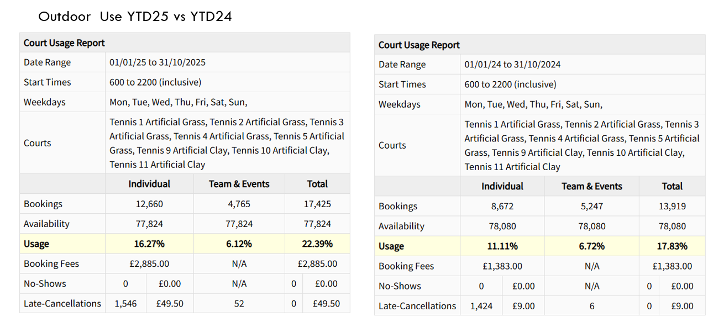  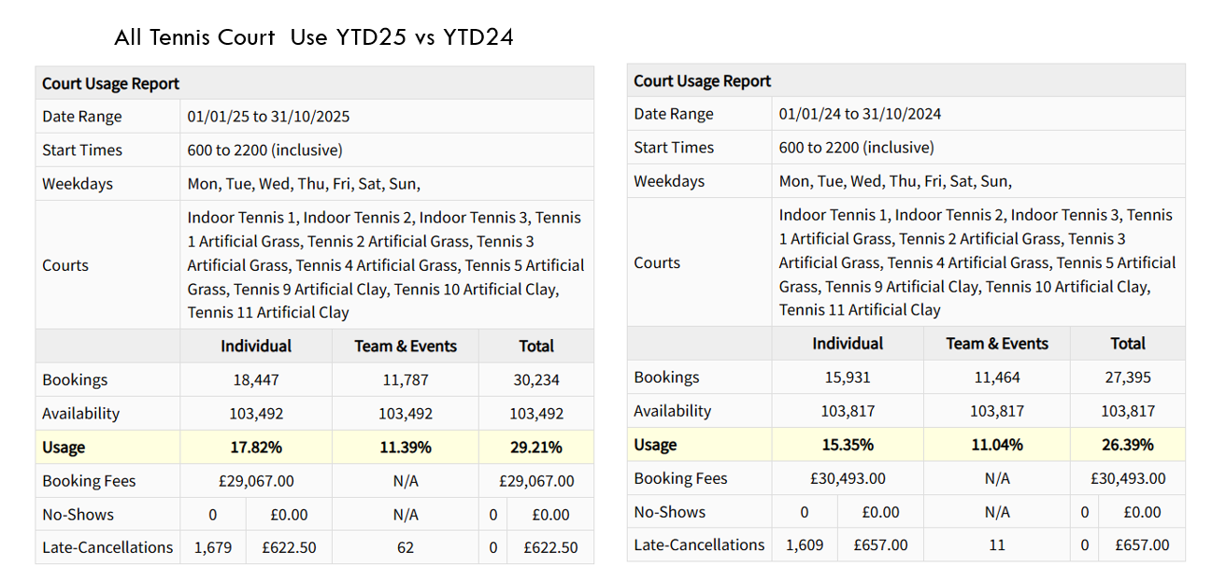  - - Indoor lighting is being addressed  - - Lump at back of indoor 3 decision to leave as is.  - - Roof leak at front of indoor 2 fixed  - LTA will have Sunday morning in tent from January at £10 per hour  - Heather Hale has stepped down from tennis committee due to work commitments  - Mike James will be stepping down from AGM. AJ agreed to look at tournaments and AF leagues.  - Meg Davies has been given an initial 6 months coach membership and is undertaking LTA accreditation. | ALL
Competitions and Internal Leagues | - Leagues going well  - Who Pairs wins finals discussed – DC to talk to NP around catering. | MJ / DC
Teams | - See comment ref captains evening | DC
Adult Programme | - Tweaks made to adult programme going well  - Discussion on mix in. At the moment Saturday mix in will remain taken off. Team specific mix in to be run on Friday night | AF
Junior Programme | - 175 juniors per week  - Holiday camps made £750 | MT
AOB | - None | ALL

Next Meeting 8th December 2025.

