<https://www.resus.org.uk/>

click on *Public Resource*

* How to save lives with CPR
* A guide to automated external defibrillator (AEDs)
* Cardiopulmonary resuscitation, automated defibrillators and the law

<https://life-saver.org.uk/> interactive animated video

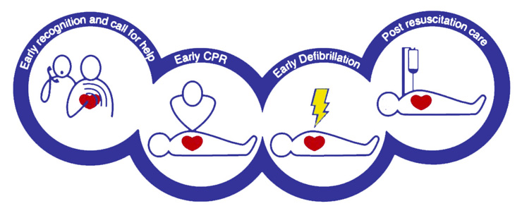

1. **Shout for help**, check if the person can answer to you or if is breathing (Does the chest rise and fall normally?) – do not get close to the face
2. **Call 999** – they will guide you and let you know if there is defibrillator close by
3. **Commence chest compression**: one hand on top of the other, interlock your fingers, centre of the chest, push hard with your arms straight (the chest should go down at least 5 cm) and let the chest rise, go fast (2 compression/second). It’s tiring – if other people present ask for a swap.

Due to COVID-19 is advisable to put a towel or a piece of clothing on the person mouth and do not attempt rescue breaths

1. As soon as the **defibrillator** is available, connect it to the person. It will tell you what to do. Not all cardiac arrests can be treated with a shock so the defibrillator might just tell you to continue with chest compression; some devices will also provide you with the right rhythm/speed for chest compression. Every 2 minutes the defibrillator will re-analyse the person’s heart and will tell you if a shock is required or not. You do not have to make any decision, just follow the instruction.

*Less than 1 in 10 out of hospital cardiac arrest survives*

*80% of cardiac arrest happen at home*

*Every minute without using a defibrillator reduced the chance of survival by 10%*

*You can make the difference!*